

FACULTY OF ENGINEERING

CINEC JOURNAL OF ENGINEERING

Author Guidelines

Your Manuscript must:
- Span 6 pages, including references relevant to the content
- Present the complete study with actual results and conclusions.

Detailed instructions for preparation of the Manuscript are given below:
Part A: Formatting Guidelines
Part B: Structure and the sections to be included

Part A: Formatting Guidelines

General
- Length: 6 pages
- Use the given template: “FOE - Sample Template”
- Paper size: A4
- Font style: Times New Roman (TNR)
- Font size: specified under each section
- Line spacing: specified under each section
- Header from Top – 8 mm, Footer from bottom – 13 mm
- Margins: Top, Right, Bottom – 20 mm, Left – 25 mm
- Page numbering: Bottom Right corner – TNR Size 11

Manuscript Title
- TNR – Size 18 – Line spacing 1.0 – Centered
- Length: 3 Lines (Maximum)
- Use Title Case style (Capitalize each word of the title)
- Leave a single space between the title and the author details
- Subtitles should not be included under the main title
- Do Not Use Symbols, Special Characters, or Math in the Title

- Example
Geometry-informed Magnetic Sensing for Real-time Control of a Soft Wrist-assistive Device
Third Line if Necessary

Authors
- Author names – TNR – Size 10 – Centered - Line spacing 1.15
- Author names must be written with Initials
- Affiliation must be marked after the name as a superscript number
- Corresponding author must be the research supervisor and marked with an asterisk
- Author names must be separated by a comma

- Affiliations – TNR – Size 10 – Italic - Line spacing 1.15
- Affiliation number must be placed in front of the affiliation
- Affiliation must be written as Faculty/ Department, Institute/University, Country
- Each affiliation must start on a new line

- Correspondence details - TNR – Size 10 – Centered - Line spacing 1.15- underlined
- Correspondence details must be written as *Email of the Corresponding Author, Institute/University
- Example
First Author1, Second Author2, and Third Author3*
1School of Mechatronic Systems Engineering, Simon Fraser University, Canada
2University of Groningen, Kapteyn Astronomical Institute, the Netherlands
3California Institute of Technology, USA
*Corresponding Author@sfu.ca

Section Subheadings
- All subheadings (Abstract, Introduction, Methodology, Results and Discussion, Conclusions, and References) included in the Extended Abstract must be formatted as TNR, Size 12, Upper Case, and centered.
- Example
ABSTRACT
- Introduction, Methodology, Results and Discussion, and Conclusions sections must be numbered using I, II, III, IV. (Refer to the provided template).
- Abstract and References section headings should not be numbered.
- Example
I. INTRODUCTION

Secondary headings
- If you need to add a secondary heading within a section, it should be formatted as TNR, Size 11, Title Case, Italic, and Left Aligned.
- Example
Hardware Design

- If multiple secondary headings are used within a single section, each secondary heading should be marked with an uppercase letter to emphasize the flow of information.
- Example

- Hardware Design
- Real-time Mid-Level Controller

Body Content Text
- Body content under each section must be formatted as TNR – Size 11 – Justified
- Line spacing must be kept at 1.15
- A single space must be used between paragraphs.

Figures, Charts, Diagrams
- Figures, Charts, and Diagrams can be included in any section and must be centered within the margins.
- Every Figure, Chart, or Diagram you include must have an importance and a purpose, and all of them must be referred/ described within appropriate sections.
- All Figures, Charts, and Diagrams must be high resolution (300 DPI minimum) and any words/letters/symbols included within the image must be clear and must be larger than font size 9 or equivalent for clear visibility.
- Depending on the importance and the included details, image size should be decided. Unnecessarily large images must not be used to fill up the space of the Extended Abstract.
- Multiple images can be included within a single figure, but each must be captioned and referred to appropriately.

- All Figures, Charts, and Diagrams should be captioned as ‘Figure #. Description’ and centered below the figure. Caption formatting must be TNR – Size 10 – Centered with 1.15 Line spacing.
- The entire caption must be Italic. But only the ‘Figure #.’ section must be bold.
- Example
Figure 1. Magnetic tracking concept for a wrist-assistive wearable robot
- If multiple images are included within a single figure, each image must be marked at the top left corner using uppercase letters in the correct sequence or order.
- The same uppercase letters within brackets must be used for the caption, separated by a comma. (Refer to Figure 1 on Page 2 of the Template)
- Example
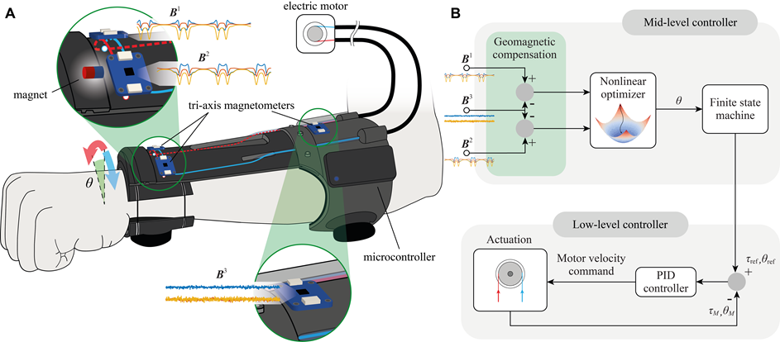
Figure 1. Magnetic tracking concept for a wrist-assistive wearable robot. (A) Illustration of the adapted exosuit design proposed by Su et al. [9], (B) Overview of the exosuit control scheme.

Tables
- Tables must be placed within the margins of the page.
- Information inside table cells must be centered or properly organized without unnecessary spacing.
- Tables must be captioned as ‘Table #. Description’ and must be placed above the table.
- Table caption formatting must be TNR – Size 10 – Centered with 1.15 Line spacing.
- The entire caption must be Italic. But only the ‘Table #.’ section must be bold.

- Example
Table 1. Comparison of Wearable Sensing Modalities

Equations
- All equations must be written using the Equation Tool in Font size 11.
- Equations must be captioned as ‘Equation (#)’.
- The equation must be centered, and the caption number must be right-aligned.

- Example
$θ=arctan {\left(\frac{r_{x}}{r_{y}}\right)}^{4}$ Equation (1)

Part B: Sections to be included in the Manuscript

ABSTRACT
- An abstract (a concise summary of the extended abstract) of 200-250 words arranged as one or two paragraphs should be included after the author details section.
- It should briefly state the problem, aim/objectives, the specific methodology, or technical approach used, primary simulation or experimental results, and key conclusions.
- Do Not Use Symbols, Special Characters, Footnotes, or Math in the Abstract.

- Keywords: At the end of the abstract paragraph(s), a maximum of five keywords separated with commas must be included and arranged in the order of importance, aligned to the left margin.
- The word ‘Keywords:’ must be bold and the keywords must be Italic.

- Example
Keywords: Strategy, Amplitude Variations, Engineering Discipline, Finite Element Analysis, Optimization

I. INTRODUCTION
- Keep the introduction concise and focused.
- Avoid broad, non-specific historical contexts.
- The introduction section must contain the following.
  - A brief description of the background/context of the research
  - Problem statement
  - Brief review of the relevant Literature (Theoretical and empirical gaps that the researcher is addressing, a concise comparison/review of related seminal work and key theories, State of the Art)
  - The research gap(s) you have identified and are trying to address
  - Research question(s)
  - Scope, Aim, and Objective(s) of the research, and the limitations

II. METHODOLOGY
- Briefly describe the theoretical framework, mathematical models, experimental setups, or computational simulation strategies employed.
- Provide brief but sufficient detail so that an expert in your specific field could replicate the approach.
- Include images, photograph(s), and other relevant visuals to explain the research methodology (e.g. experiment setup)
- Include key mathematical formulations or governing equations, but omit tedious step-by-step derivations.
- Use block diagrams, flowcharts, or high-level schematics to explain the processes and methods.
- Specify experimental conditions, simulation environments (e.g., MATLAB, ANSYS), or materials used.

III. RESULTS AND DISCUSSION
- Present your experimental findings, empirical data, or modelling/numerical results.
- It is highly recommended to use clear visual aids (such as the most important images, graphs, schematics, or tables) to summarize quantitative insights, while comparing your results against baseline or existing standards or findings of previous studies in the literature.
- Discussion should be carried out based on the findings of the current research with adequate evidence and comparison with previous research available in the literature.
- Interpret data patterns directly in relation to your original objectives and research questions.
- Highlight specific engineering metrics like efficiency gains, error reduction, structural load capacities, or processing speeds.

IV. CONCLUSION
- Conclusions should be matched with the aim and objectives of the research.
- Reiterate the most significant achievements of the research.
- Describe the importance of your findings, how it affects your research field/engineering domain, and the potential applications.
- Provide recommendations: Briefly describe what can be done in future studies (e.g., scaling the prototype, testing under different conditions, using different materials, etc.)

REFERENCES
- When using references throughout the abstract, DO NOT include all the original references you used from the initial stages of the research.
- Instead, select 5 to 10 most significant, key references out of them all and use them when writing the Extended Abstract.
- Stick strictly to the IEEE style and format when citing within body content text and when preparing the list of References.
- ‘References’ section formatting: TNR – Size 10 – Line spacing 1.15 - Justified

- Manuscripts that have been submitted for publication, but have not been published yet, should be cited as “unpublished”.
- Manuscripts that have been accepted for publication should be cited as “In Press”.
- Capitalize only the first word in a paper title, except for proper nouns and element symbols.

